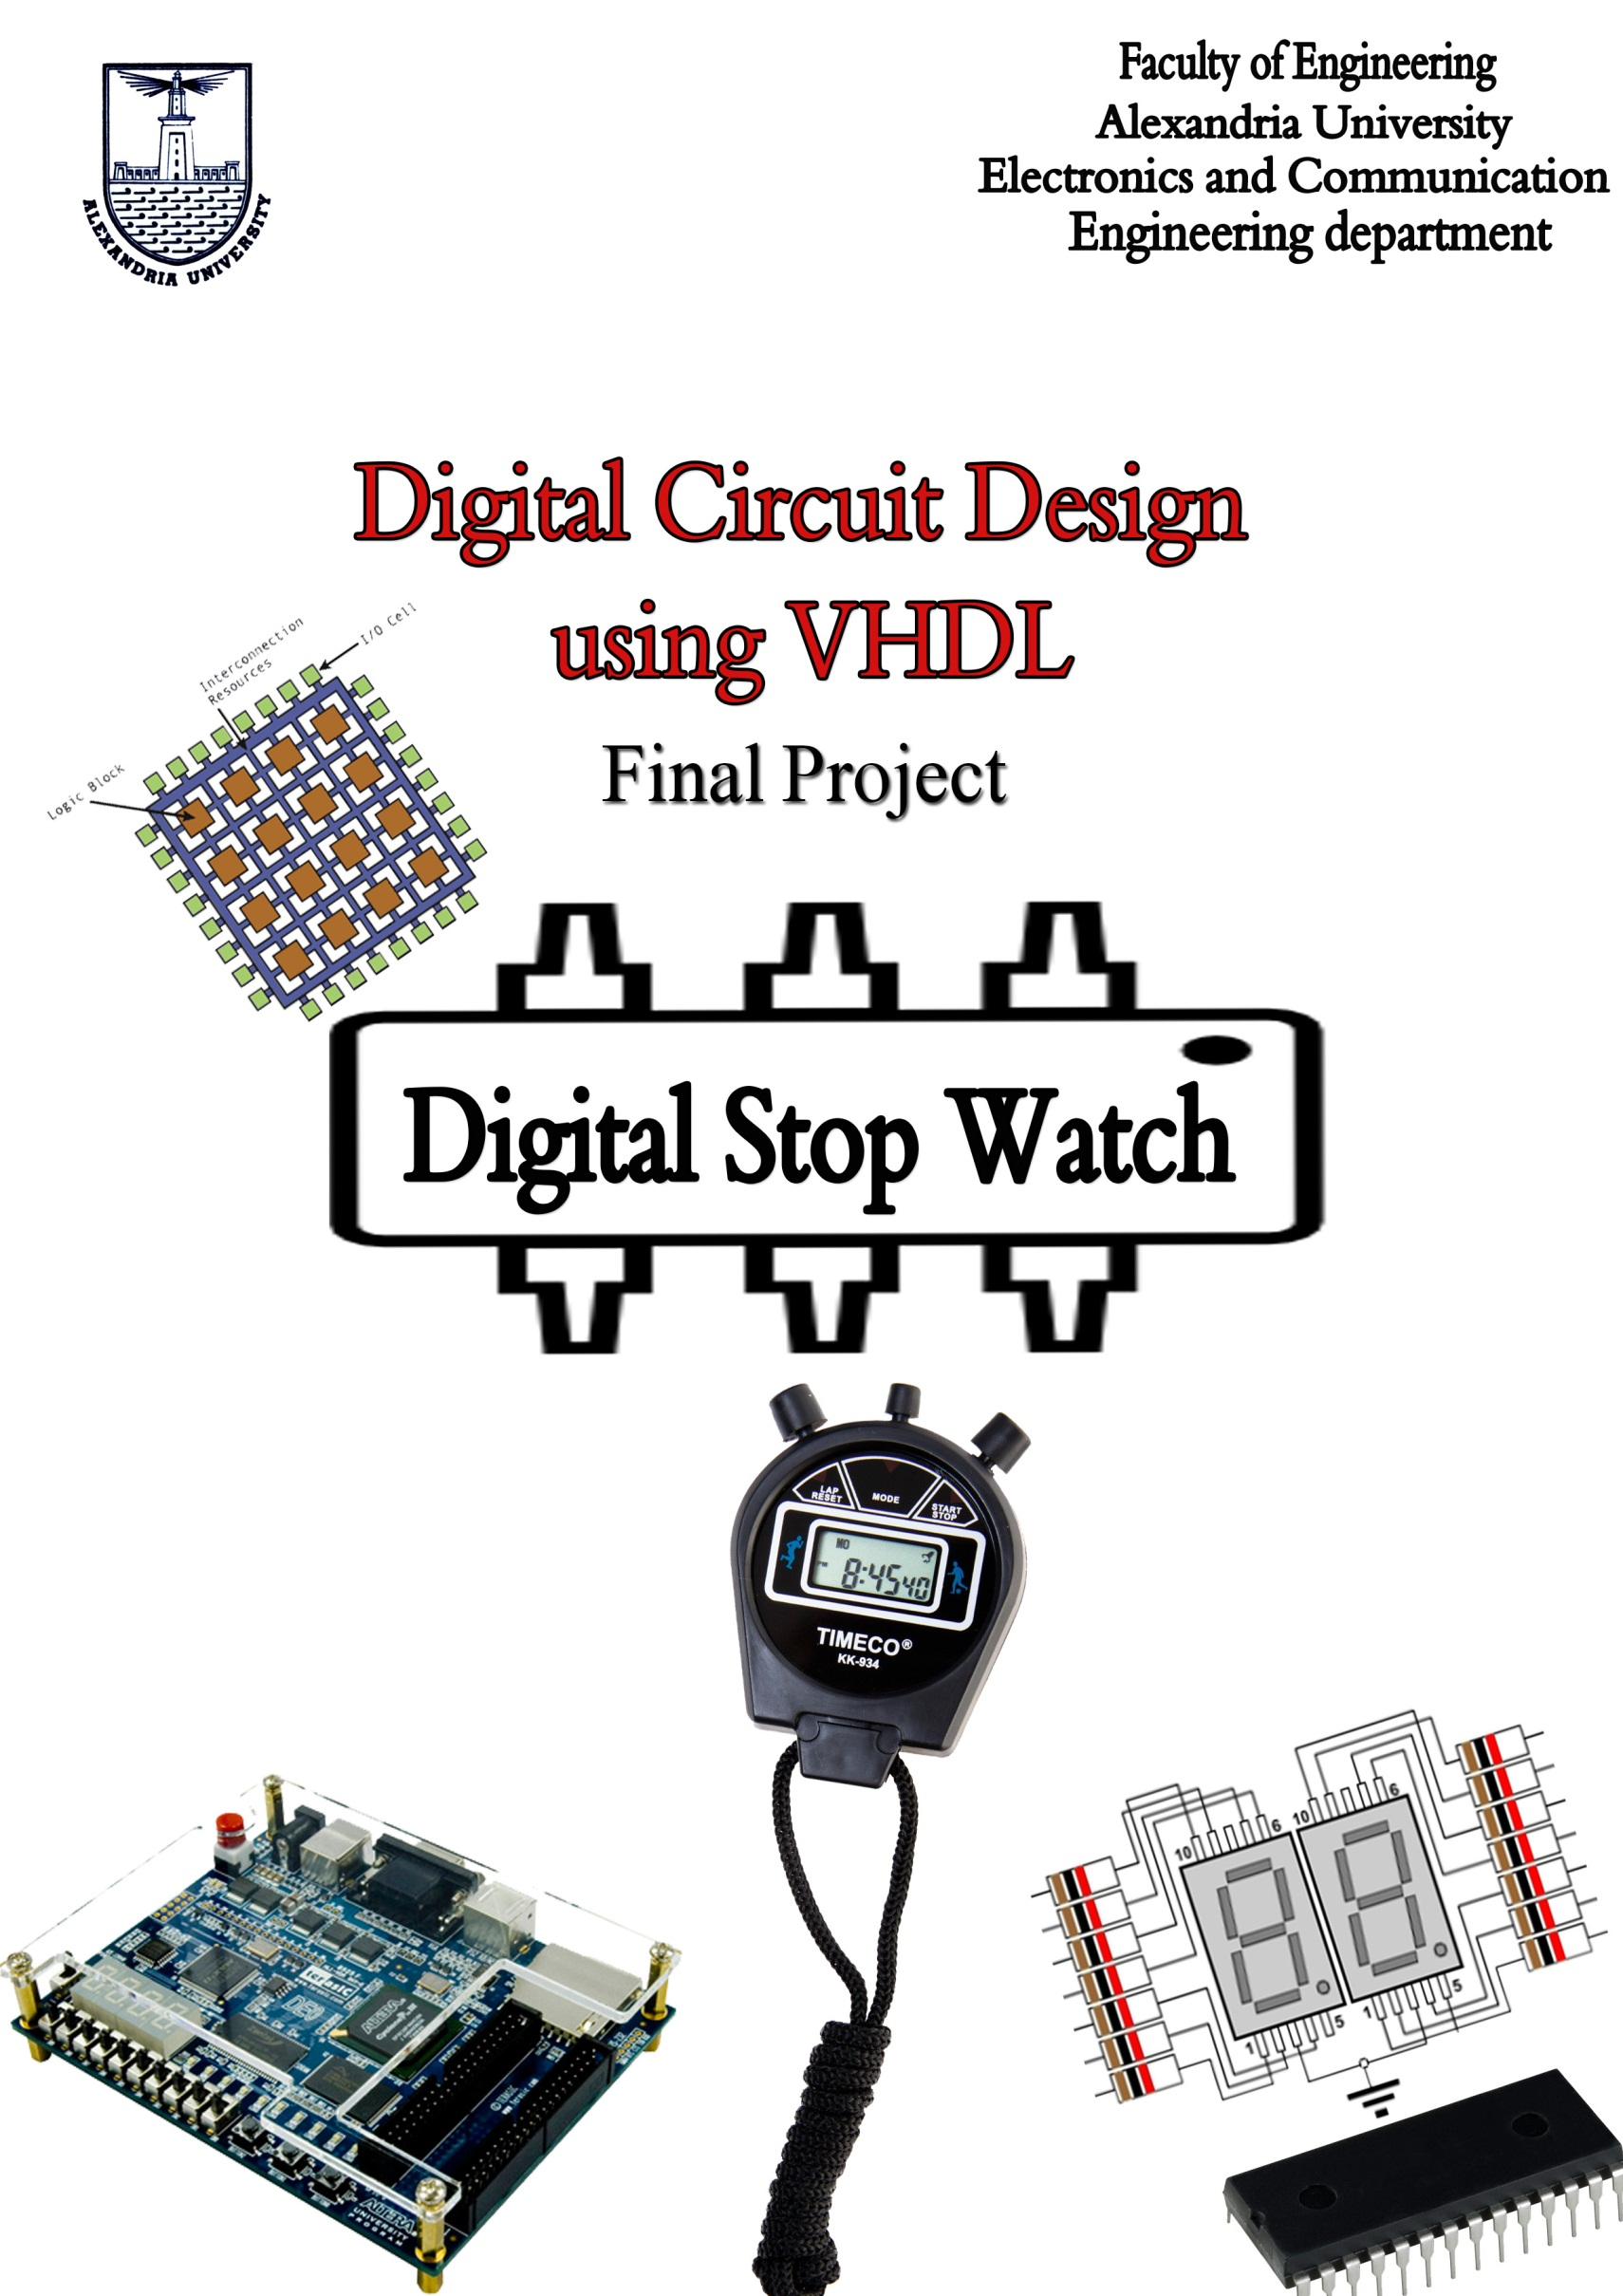

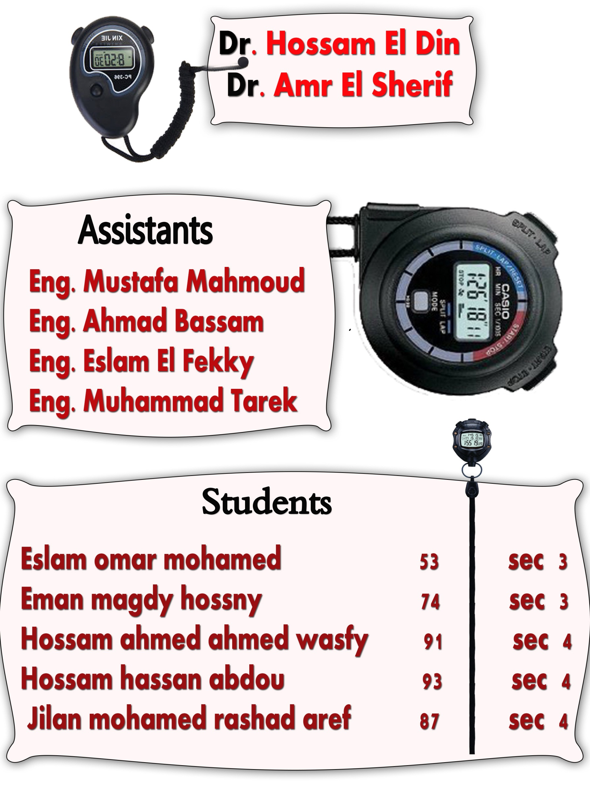

**Subject:**

Design a digital stop watch it has 4 inputs

-**Clock:** is 1Hz which equivalent 1 second

-**Seconds, Minutes**: initial values which stop watch begin to count from its.

**-Start/Stop**: button used to start count and stop it.

and 3 output

**- Seconds, Minutes:** counting value (remain value).

-**Finish:** used to determine the finish of counting.

* For input  
  -**Seconds, Minutes** will be in BCD.

- **Start/Stop** will be active low.

* For output

- **Seconds, Minutes** will show in seven segment display.

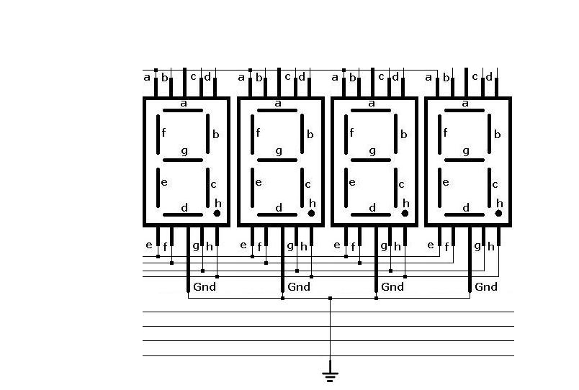

**Steps**:

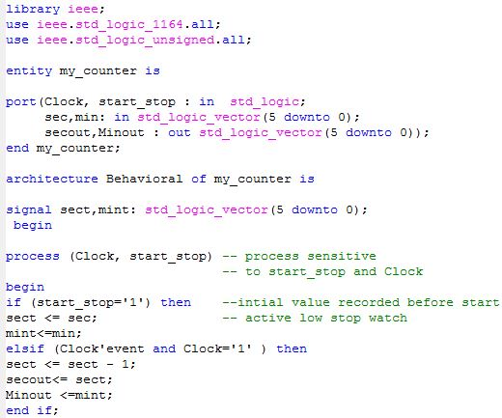1-Firstly we use binary counter used to count down from initial value which user enter it before started.

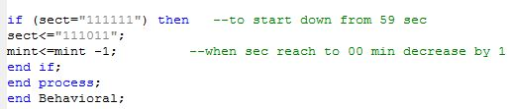

**2**-use BCD to Binary Code to convert BCD input to Binary

And use it as a initial value for counter .

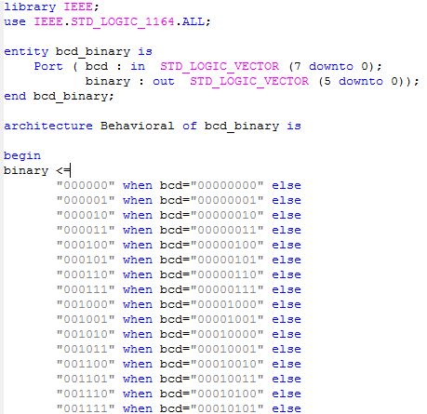

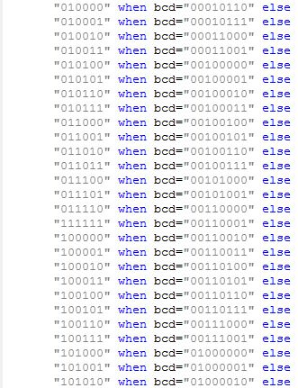

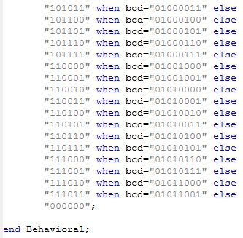

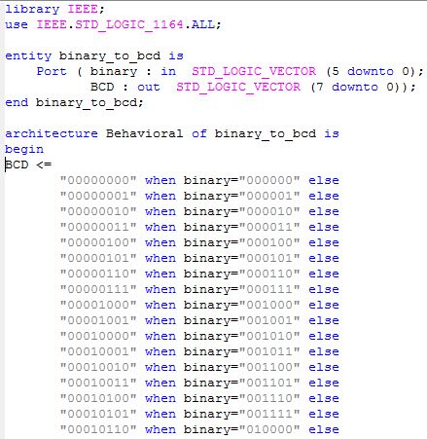**3-**usinga code witch convert the Binary output to BCD

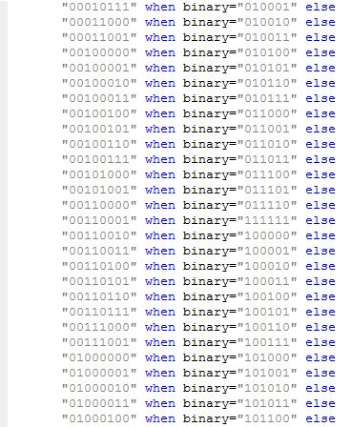

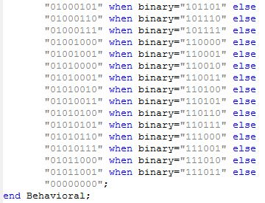

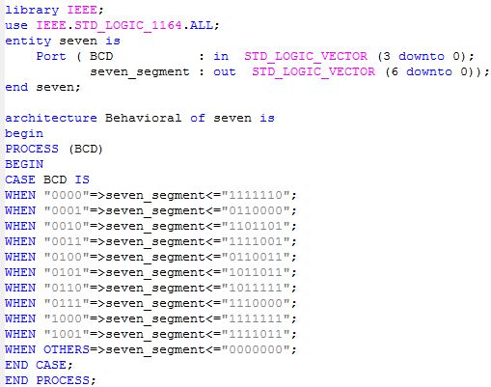**4-**finally we use code which convert BCD to seven segments.

-Pervious **codes** will use as **components** in top modules code

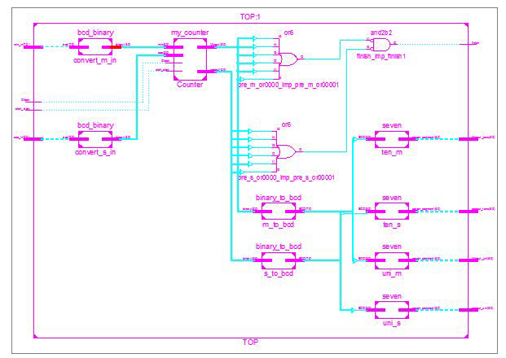

**Components in Top module**

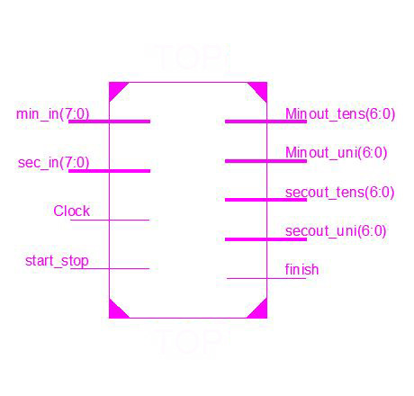**Top module layout**

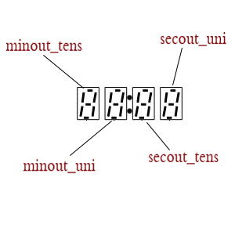

**Top module code:**



